Procedural Content Engine

Game Design Document

## Created By

This procedural content engine was created by Will Pye and uses several assets from outside source. These assets are listed in the Assets subsection.

## Game Overview

The Procedural Content Engine is the precursor to future games that use procedurally created worlds. There is currently no overarching goal of the game, besides the ability to explore an infinite world.

## Game Rules

This game has no rules, no objectives, or anything else besides a procedurally generated world. The world is limitless, so pick a direction and see what you can find.

## Controls

The controls for this game are fairly basic and are as follows:

* WASD are used for moving
* Space for jumping the
* mouse for camera rotation
* Shift to sprint
* Esc to access the UI exit button

## Art

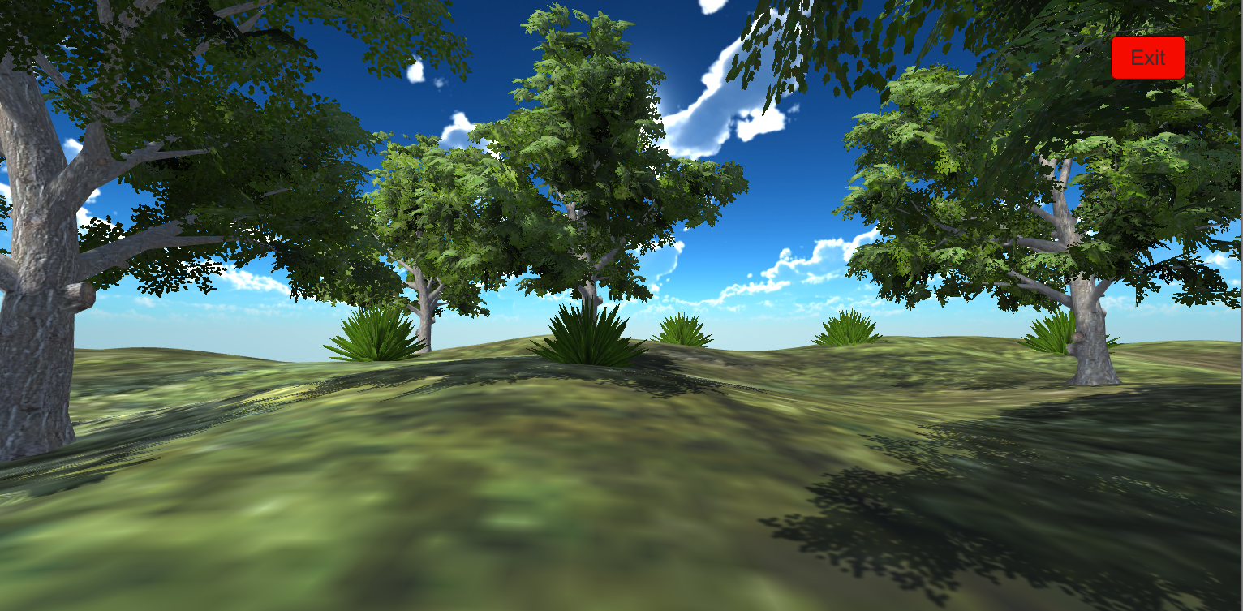

The Procedural Content Engine creates an infinite world for the player to explore. In its current iteration, the engine creates a grassy and hilly world populated with trees, shrubs, and cacti. The game also boasts a beautiful blue skybox to give players a feeling of comfort and joy.

## Assets

* First Person Controller and Tree Models from Unity’s Standard Assets
* Shrubs and Cacti from Yughues’ Free Decorative Plants
* Skybox from AVIONX’s Skybox Series Free

## Wishlist

* Add a game objective, such as collecting loot and fending off enemies.
* Add weapons such as rifles.
* Develop the Engine to support different biomes and more variability of the terrain.
* Add ambient noises and better walking audio.